Personal Notes

**Date:** June 13, 2019 **Time:** 1300 **Location:** VTRC Room 332

Attendees: Mr. Fontaine, Simona Babiceanu, Joseph Keogh

* **Answers**
  + Roles/responsibilities and transition of work to Joey
    - Whatever works is good
  + Overall project tasks and timeline
    - See plan below
  + Major tasks for next week
    - Get data downloaded
    - Have information flow plan
    - Have code plan
    - Have code skeleton
  + Plan for regular meetings/updates
    - Whatever, Fridays
  + Objectives/deliverables (possible TRB paper?)
* **Plan**

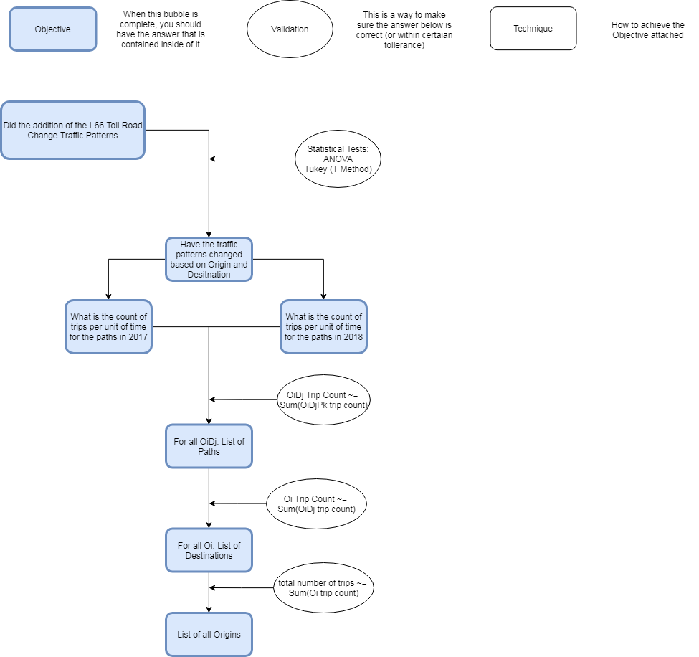



* + OD Definitions
    - Both
      * End up with a list of Origins and Destinations
    - Unbiased Grid
      * Have an analysis grid
      * Each section of grid works as start or end point
        + Can have a separate grid for each
      * All options covered
    - Select biased sections
      * See where most popular sections are
        + By zipcode, general area, on off ramp etc
      * Double Bias
        + Based on the Origin section, create destination sections
      * Have to assume that the Origins and Destinations are not changing
  + Path Definitions
    - More Bias
      * Create exact paths
        + What we were doing earlier
        + I-66E – 495N – GW Parkway S – I-66E
    - Less Bias
      * Road Sections
        + Have identified sections of road that are of interest
        + Create a path that the trip followed based on these road sections

Allows for stops: if someone pulls off to buy groceries, this will pick them back up when they keep going

* + - * More general view of what is going on
  + Code
    - Want to create own objects
* **Questions**
  + Getting “Unexpected end to data”
    - 2018 waypoints.csv5
    - 2017 only one file
  + Can Python handle/ convenient to handle what I want to write
    - Pointers etc
  + Data
    - Do I need an Inrix account
      * They have emailed me asking for a phone call
    - Which data folders to use
    - What each folder contains
      * Rows, how the data links
  + Does threading help with file reading
    - Even though it is the disk that is being overloaded during unzipping and reading
    - Can utilize full potential of the disk and other resources
    - Having to wait 2 hours is unacceptable
    - Talk to Prof. Gerber?
* **Need/Want**
  + Road segment identifications
    - Whole road
    - Paths
    - Sections of road
      * Used to build paths off of
  + Any code that analyses trip data

**Notes**